Mohamed Ashraf ***Name /***

***B.N /***

***DATE /*** 5/6/2021

***TOPIC /*** DATA BASE

## SCREENSHOTS /

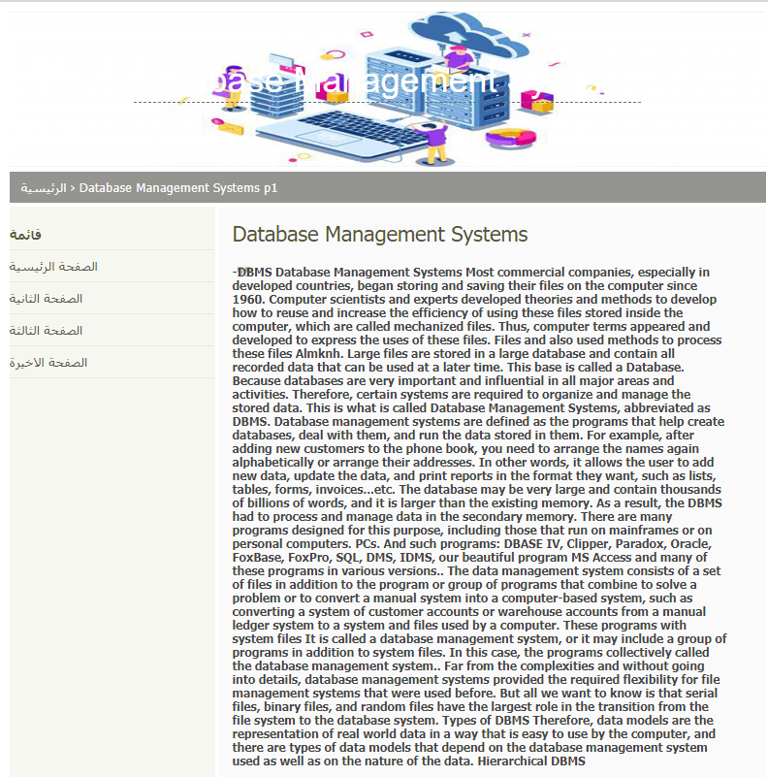

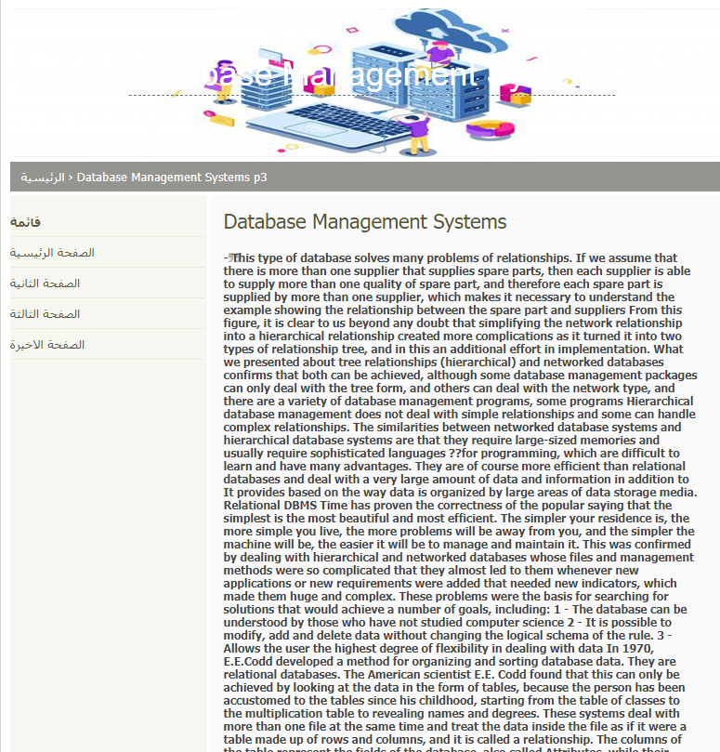

## SOURCE CODE :

